Elaine Mele, DPT, PYT, SWLC
Doctor of Physical Therapy, Professional Yoga Therapist, Social Worker Licensure Candidate
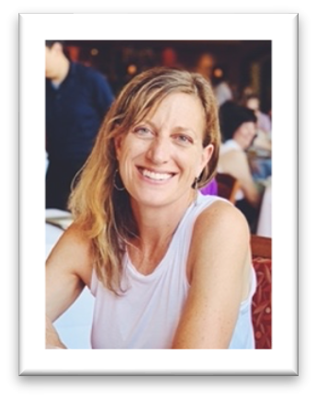
About Elaine: After 27 years working as a Physical Therapist, I decided to return to school to earn a master’s degree in social work (MSW). I graduated with my MSW in 2025 from Western New Mexico University (WNMU) in Silver City, NM and I am pursuing my goal to work in private practice as a counselor. During my physical therapy career, my areas of expertise included issues such as chronic pain, chronic disease, women’s health
and disability. I have a particular interest in Women’s Health and Developmental Disability, but all are welcome!
Disclosure: I understand that as a social work licensure candidate (SWLC Lic. #81082), Elaine will be working under the supervision of Chris Nordstrom, LCSW (MT Lic. #695). Additionally, as the owner of Counseling Associates Tracy Vaughn LCPC/LMHC, will provide additional consultation. To be supervised in accordance with the Montana State Board of Behavioral Health, I understand Elaine may discuss portions of our sessions with her supervisors including my name, date of birth (DOB), address and specific content of our psychotherapy sessions. I acknowledge that Tracy Vaughn will have additional access to selected case information as it pertains to his responsibilities for on-site supervision and for billing purposes. This includes my name, DOB, address and insurance information. I have been informed that all parties follow HIPPA guidelines to protect my information and that all my information will be kept private as part of the legal and ethical standards set by their licensure.
I understand that, in accordance with ethical and legal obligations of counseling, my information might be shared without my consent in the following instances:
- In the case of suspected abuse or neglect against a child or vulnerable adult.
- In the event you pose a danger to yourself or others
- In the event of a court ordered appearance
- For the purpose of an involuntary hospitalization

_______________________________________ _____________________
Client Date

_______________________________________ ______________________
Guardian (if applicable) Date

_______________________________________ ______________________
Elaine Mele, SWLC #81082 Date

2

